Day 7: 20 Sep. 25

Web Service : Giving the service for web application when both the application running using different technologies.
Spring boot or express
Amazon
Payment - Credit card
Debit card
Paypal asp.net
Paytm php
Gpay express js
PhonePay spring boot

JS object ------ request
App1 XML/JSON App2
Express JS Java
--------Java object –response

XML :eXtensible markup of language: data need to share in tag format.
JSON: Java Script Object Notation: data need to share in key/value format.
Web Service
- SOAP base web service: Simple Object Access Protocol.
In SOAP Web Service we can consume and produce data only in the form of XML
SOAP Web Service follow its own message structure
In SOAP Web service we need to send and receive the data only in the form of XML with SOAP structure.
SOAP web service base upon SOA architecture. Service Oriented Architecture.
- Rest full web service: Representation state transfer . In Rest full web service we can consume and produce data in any format base upon client requirement like JSON, XML, Plain text, html or any mediate type etc.

Creating simple REST full Web service

Create the folder as SimpleRestAPI
npm init -y package.json
npm install express
Open the folder inside a VS Code

Creating Rest API for Product with Array concept or file or database.
Array concept
- Get method : get the resources
  - Get all product in json format : select query
  - Get particular product base upon some property like pid, pname, price
    - Query param
URL?key=value
URL?key1=value1&key2=value2
    - Path param
URL/value
URL/value1/value2

Select query with where clause

- Post method : create the resource
  - store the product details in array or file system or database
insert query
Post method data send through body part in different format like json or xml etc.

By default express js can’t extract body data from request object we need to use middleware.

Testing through post man client

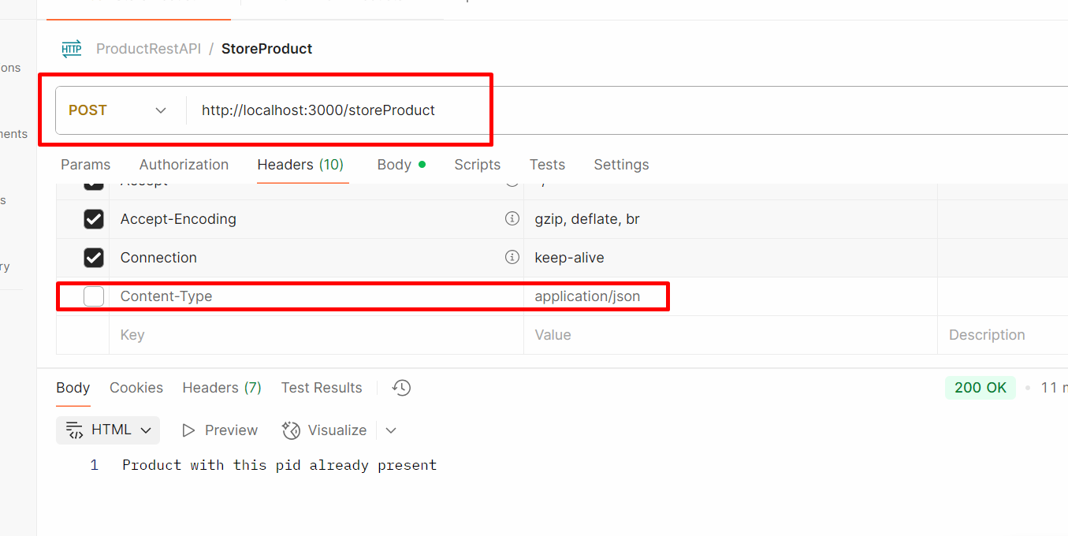

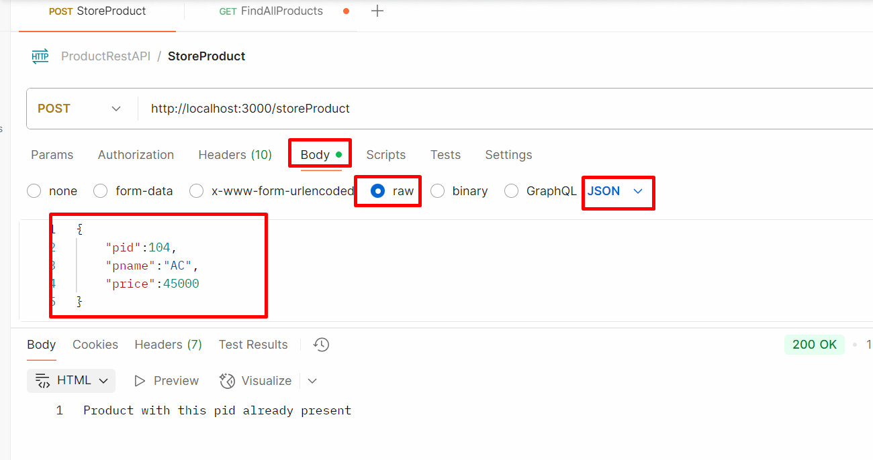

- Put method : update the existing resource
  - Update the product price using pid
Update query

- Delete method : delete the resource
  - Delete the product using pid
Delete query
To test these end or rest api we need some rest api plugin.
Post Man plugin
Only Get method we can test through browser.

Creating REST API for product object with array concept
Create the folder product-rest-api
npm init -y create the package.json file
npm install express

